Aloha and
Mele Kalikimaka!

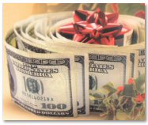

Greetings Loved Ones,

I have assembled a variety of goodies for you to download and enjoy. The theme of this package would definitely be “Attracting Abundance!” Now that’s something I’m sure that we can all relate to.

2009 was a tumultuous year for many ~ and money matters were at or near the top of the list of concerns for most people. Well, take heart ~ I have some powerful gifts and suggestions for you to empower yourself in 2010 and beyond…

This package will contain some pieces that are interactive:

YES, it will take some action on your part to maximize the effectiveness of some of the tools I’m sharing with you. Remember after all, life is a participatory sport ~ lol

So, without further ado…
Enjoy your Gifts &

May this Holiday Be the very best EVER
for YOU and YOURS!
Amber Lightfoot ~ Blissin’ Out on Maui

CONTENTS



Enjoy these gifts ~ from my heart to your heart…Amber Lightfoot

Holiday Feng Shui Money Blessing……………………………………………..page 3

Secret Check ………………………………………………………………………page 4

Gratitude Daily Journal Sheet………………………………………………….…page 5

Abundance Corner Holiday Blessing………………………………………….…page 6

Joe Vitale’s “Attract Money Now” ebook………………………………………...page 7

Marie Diamond’s 2010 Feng Shui Freebies….…………………………………page 8

Scott Katsura’s song: Mele Kalikimaka………….……………………………...page 9

My favorite Live-Your-Fantasy pic……………………………………………….page 10

Contact me and other resources…………………………………………………page 11

Enjoy! ~ shared by Amber Lightfoot ~ page 2 of 12

Holiday Feng Shui Money Blessing

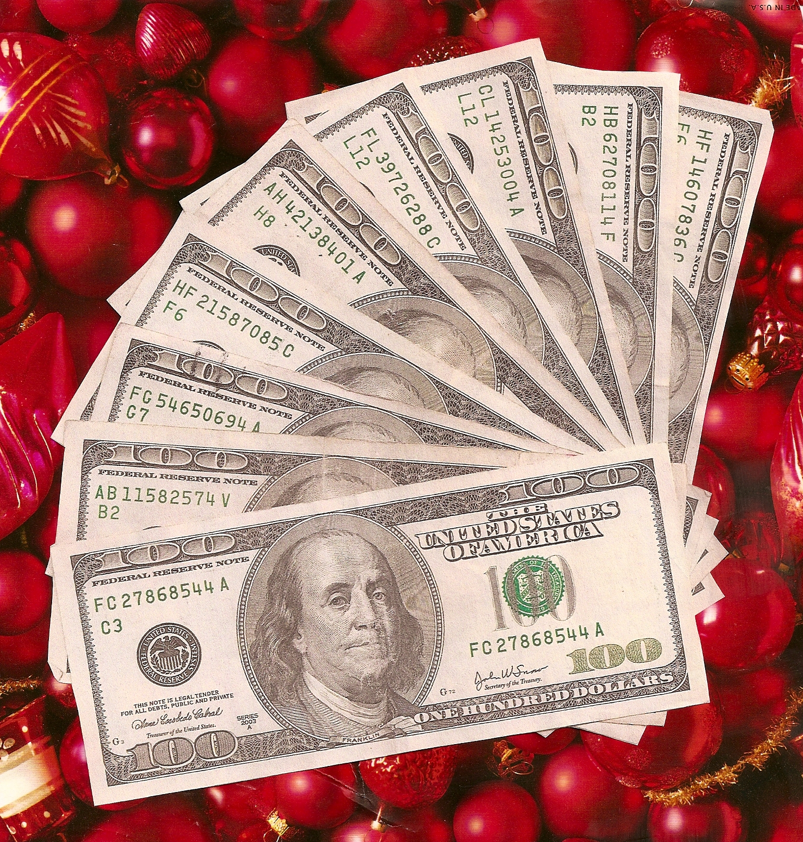

2009
Merry Christmas!

(Save this and preferably print it out, and place it in the Prosperity area of your home. The Feng Shui system which I utilize says that is the back left corner of your home from the front door.) Another way to prosper from this is to print it out and carry it in your purse of wallet. It’s good to reprogram yourself to seeing money around.
Original art:Amber Lightfoot ~ Enjoy the Gift! ~ page 3 of 12

The Secret Check

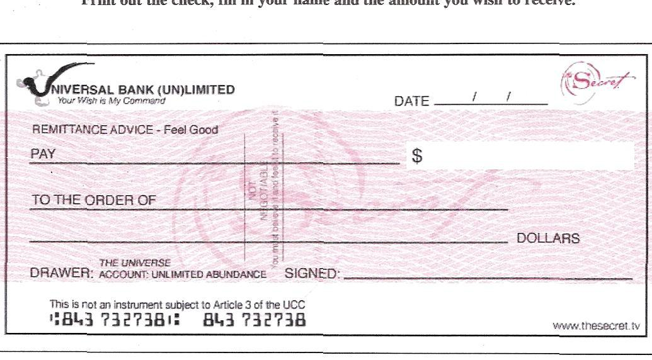

The Hit Movie “The Secret” changed my life and still is…



If you haven’t seen the movie yet, the above, boxed link will take you to their site where they have a pay-per-view option. I have the original version ~ and have viewed it over 1,000 times. It’s good to stay focused and positive while manifesting.

The Secret came into my life at a perfect time ~ I had had it with living in the desert of Arizona, and had decided to make my life dreams come true. Moving to Maui was at the top of the list, and with this film and the original “Go Gratitude Experiment” I popped my dreams into reality in 30 days!

Remember to Expect Miracles ~ shared by Amber Lightfoot ~ page 4 of 12

Daily Gratitude Journal Sheet

This little gem comes from Michael Lossier’s Book: Law of Attraction

The Beauty of this tool is that it allows one to truly see the abundance in their life. …And the more you see it and are grateful for it, the more abundance appears.
…And the more abundance that appears, the more grateful you are for it, and the more grateful you are ~ the more abundance appears!…
See where this is going? I LOVE IT ~ a spiral up!

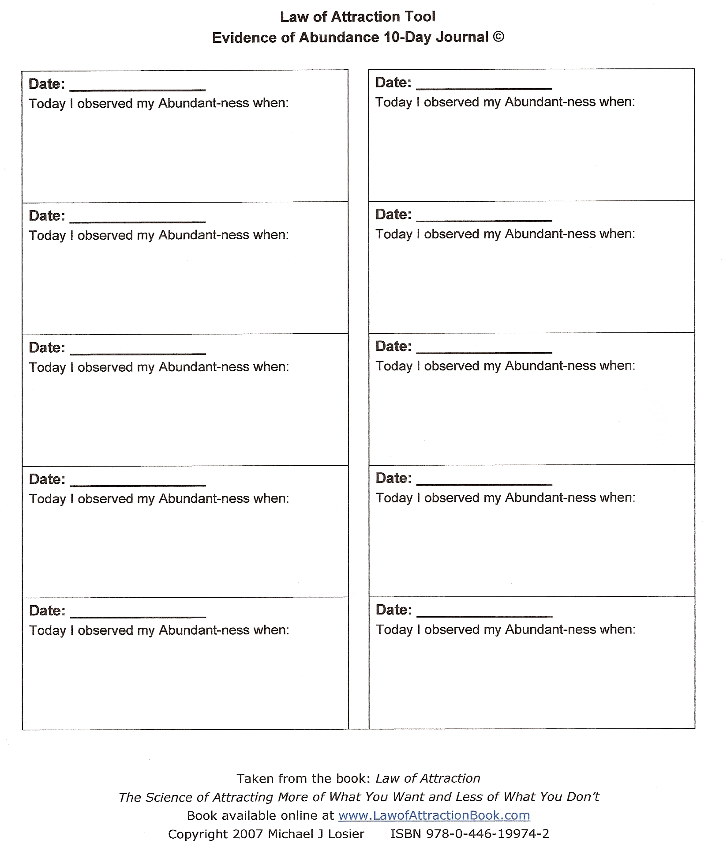

Enjoy! ~ shared by Amber Lightfoot~ page 5 of 12

Abundance Corner Holiday Blessing

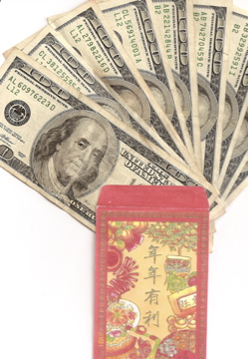

Save this and preferably print it out, and place it in the Prosperity area of your home. The Feng Shui system which I utilize says that is the back left corner of your home from the front door. Another way to prosper from this is to print it out and carry it in your purse of wallet.

Enjoy! ~ shared by Amber Lightfoot ~ page 6 of 12

Joe Vitale’s “Attract Money Now” e-book

I love this book, and have just begun reading it! As usual this guy is just rockin’ my socks off… he has a way of getting right to the heart of the matter. It was his gift to me, and now my gift to you. Enjoy!

Joe Vitale was seen in the hit movie “The Secret” and is an incredible Best-Selling Author and internet marketer. His list of books will just blow you away. Be sure to check out his site, and register for freebies too.
http://mrfire.com

Click the book cover below to begin downloading the book.
If it’s really slow, click here!



…and here’s another goodie from Joe that I just found too ~ this Money Magnet audio rocks!

Enjoy! ~ shared by Amber Lightfoot ~ page 7 of 12
Marie Diamond’s Feng Shui Freebies!

Marie practices her very own form of Feng Shui ~ the Diamond Feng Shui System which incorporates ancient Compass Teachings & Marie’s unique flair. She’s right on point with her advice. A consultant to the stars ~ enjoy her gift.

How to Attract the Money, Relationships and Success
You Are Looking For in 2010!

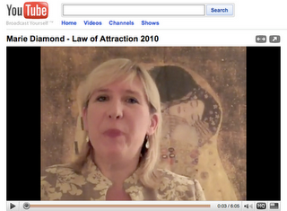

link to 2010 movie:
http://www.youtube.com/watch?v=D650IGjwni8

…and for the first video to get YOUR archetype:
http://www.youtube.com/watch?v=UNrf_1BDA7s&feature=related

I’ve had the pleasure to be in touch with her via email ~ and she rocks the planet! Her personal story is truly inspiring!

Check it out ~ you certainly have everything to gain and nothing to lose. Feng Shui has changed my life, and continues to amp my manifesting power.

Enjoy this is so cool ~ shared by Amber Lightfoot ~ page 8 of 12

Scott Katsura’s song: Mele Kalikimaka

(Mele Kalikimaka means Merry Christmas in Hawaiian)

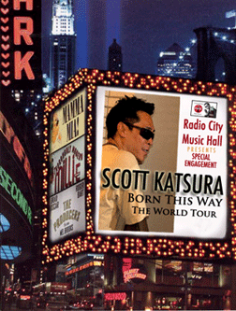

Click here to download the tune and enjoy Christmas Hawaiian Stylee!

…and be sure to check out his website too (click the pic below to go).
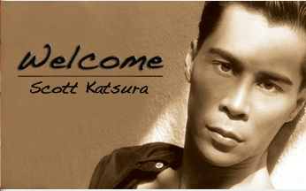
Amber Lightfoot’s Christmas Gift to YOU ~ ENJOY! ~ page 9 of 12
My favorite Live-Your-Fantasy pic!

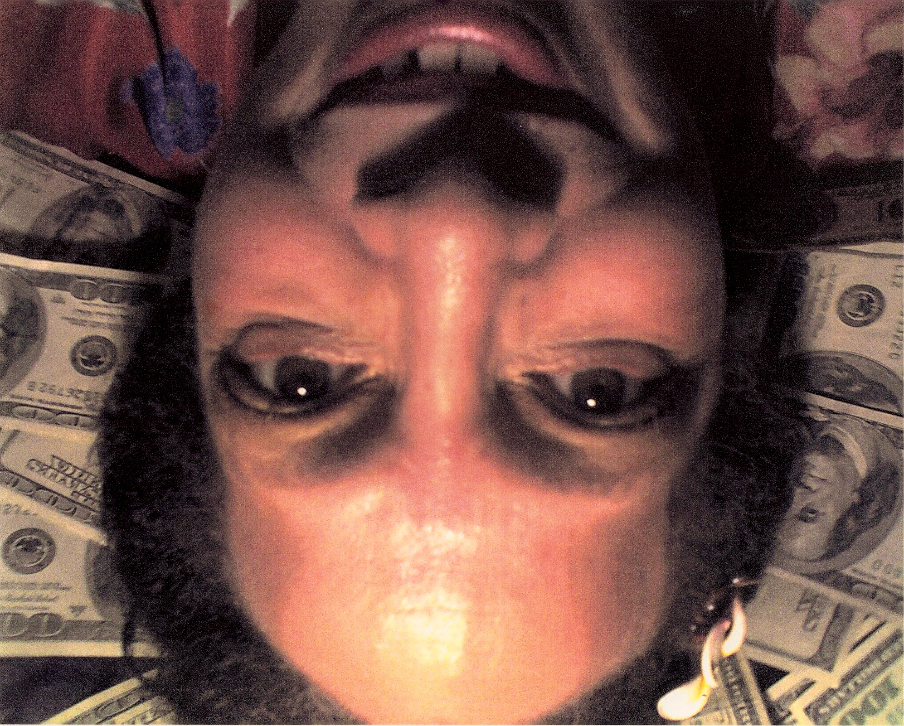

…well, at least the PG Version ~ lol

I had the fantasy of rolling around in a bed full of money – MY MONEY!
Here’s one picture of the living proof ~ it’s great fun to fulfill your fantasies.

GO FOR IT!

~ Self portrait taken on Maui ~

Enjoy ~ Shared by Amber Lightfoot ~ page 10 of 12

Contact me… and other resources!

It is my hope that you thoroughly enjoy this offering and the many blessings that these tools provide. The most important factor in Law of Attraction is YOU. What are you thinking, Right NOW? Would you like to see that happen now?
Remember to stay focused on what you want ~ that truly is the key.
(Ask and you shall receive…)

Wanna Stay in Touch?

Regular updates to my blog “Amber’s Light!” at:
http://amberlightfoot.blogspot.com/

Check me out on Facebook ~ Amber Lightfoot

Email: wownow4u@gmail.com

Some other great resources!


the symbol for Gratitude
from: Go Gratitude’s Stacey Robyn

As mentioned a bit earlier it was the Go Gratitude Experiment and the movie “The Secret” that were simultaneous catalysts for the major changes in my life. I will always be grateful to Stacey for bringing me back to
THE MASER KEY ~ Gratitude!
We’re currently involved in the 42-Day World Gratitude Movement and it is manifesting my dreams at lightening speed. Yeah, Baby!!!! =)

Enjoy! ~ shared by Amber Lightfoot ~ page 11 of 12

More Great Resources…

Connect with Law of Attraction Groups to keep you focused on the positive. Look for a LIVE group ~ or join one of the thousands online. There is power in synergy. Remember where 2 or more are gathered…

Hit up the Facebook Fan Pages of HUGE people who inspire you. The internet has made the whole “Six Degrees of Separation” thing obsolete. EVERYTHING is just a click away and even famous people are very much accessible.

I am a book junkie (can’t help it, I’m an author), so I stay tuned in to Amazon. In fact, I’ll be putting together an Amazon Store soon ~ and am about to upload my books to Amazon for sale. YUMMY! …So my advice is to shop at Amazon often! lol

I am also a big fan of Hay House and Louise Hay is one of my SHeros! She (via Hay House) represent some awesome, inspiring folks. Treat yourself to a good spiritual retreat.

I have just discovered Twitter and love it! Everyday I am turned on to amazing things there… follow me!

YOUR INNER VOICE!
You are a spark of the Divine.

Ok, more updates later ~ but I gotta fly for now! I hope you enjoyed this digital Christmas Present and can feel the love and blessings in my heart for YOU! Let’s get ready for 2010 ~ the very best year of our lives…

Lotsa Love and Gratitude!
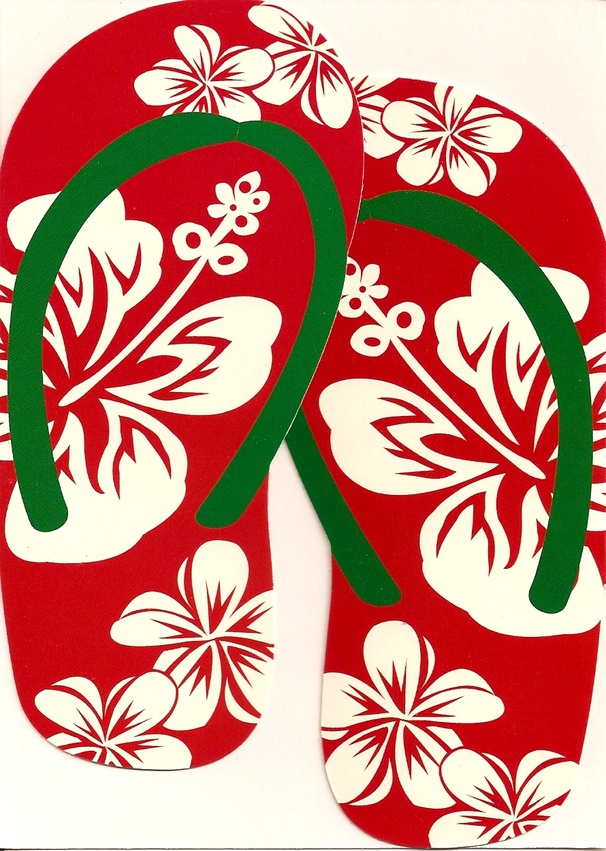

Walk in Beauty,
Amber Lightfoot ~ Blissin’ Out on Maui
Page 12 of 12

